Rotary Club of Kathmandu Mid-Town
Breakfast Chatter



10 November 2006 The Weekly Bulletin of Rotary Club of Kathmandu Mid-Town Bc # 19 of 2006-07

District : 3290 Web: www.rotarymidtown.org.np Club Id : 26776

NOVEMBER IS THE ROTARY FOUNDATION MONTH
The mission of The Rotary Foundation is to enable Rotarians to advance world understanding, goodwill and peace through the improvement of health, the support of education and the alleviation of poverty. The Rotary Foundation is a not-for-profit corporation that is supported solely by voluntary contributions from Rotarians and friends of the Foundation who share its vision of a better world.

Rtn Dr Isabella CB Khadka provided a presentation on her past reminiscences
at the Club meeting on 3 November 2006 .
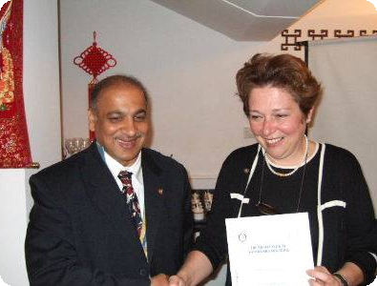
a) Dr Isabella listening to the comments by the club members after her presentation,
b) President CK Golchha shaking hand with Dr Isabella after presenting her a Letter of Appreciation for
her talk program at the club meeting as the inhouse speaker.

Weekly Meetings and Programs :
Date | Program/Speaker | Program/Topics of Presentation
10 Nov 2006 | Muna Shrestha | Waste management as our social responsibility
17 Nov 2006 |  | Charter Night Dinner meeting
24 Nov 2006 | Juergen Dahm | Helping poor children of Kathmandu

Friday, 10 November :
Ms Muna Shrestha will be talking on varied aspects of waste management vis-à-vis citizen's roles and responsibility in the society. People live in society and they have social responsibility to manage their wastes. She will be emphasizing on four R's – Reduce, Recover, Re-use and Re-cycle.
Muna is associated with Jamarko, an organization which collects waste papers, recycles and produces handmade paper products.

Rotaracts' Charter Day Celebration :
On Sunday 5 November 2006 Rotaract Club of Kathmandu Mid-Town celebrated 9th Charter Day by holding a joint-meeting with Interact Club of Kathmandu Mid-Town Kirtipur/Paanga at Sanchetana Primary School in Dhobighat, Lalitpur. Altogether eight new members were inducted to Rotaract Club by the Chief Guest, District Secretary Gopal SL Kakshyapati on the occasion. President CK Golchha and AG Dr C Lekha Tuladhar were present at the Charter Day celebration.

School building Inauguration :
A team of Mid-Towners led by PP Ambica Shrestha visited Hetaura for inauguration of an extension building attached to Shree Rashtriya Rotary Lower Secondary School at Manahari, Hetaura. The block is named as Tehaar-Ambica-School. PP Ambica inaugurated the school building at a program organized for the purpose on Thursday, 9 November 2006 at the School.
Tehaar-Ambica-Trust Chairperson Ambica Shrestha and Mid-Towners were given a very warm welcome by the School students and management committee.
Vocational Service Director Govinda Chipalu gave away school bags and other scholarship materials to 41 Chepang students of Class one on that occasion.
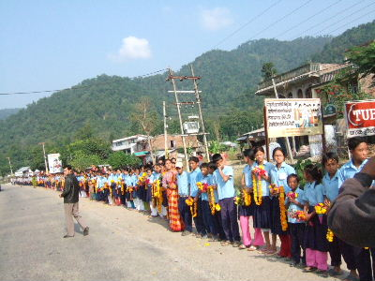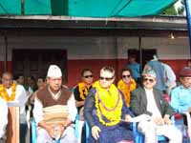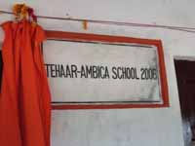
The Mid-Towners who witnessed the program were:
PP Ajay Sthapit, PP Arun M Sherchan, VSD Govinda Chipalu, Secretary Rabi Karmacharya, Rtn Isabella CB Khadka, and CSD RR Shrestha.
Earlier on 8 November the team visited the Hetaura Community Eye Hospital, a joint-project of Tilganga Eye Centre and Rotary Clubs of Nepal where the team was given briefings on the progress of the project.
The team of Mid-Towners also attended the weekly meeting of Rotary Club of Hetaura held on the same day evening at Hotel Rapti.
President Arun Subedi of RC Hetaura hosted a cocktail dinner in honour of the visiting Mid-Towners' team at Avocado Hotel in the evening.

On Lighter Side : Click at the figure ⇩


It’s almost impossible to imagine Rotary today without The Rotary Foundation. So much of what Rotary is known for — international service projects, grants, scholarships and, above all, PolioPlus — depends on the Foundation. Without the Foundation, Rotary could never have grown into a truly international organization.
RI President William B. Boyd

10 November 2006 The Weekly Bulletin of Rotary Club of Kathmandu Mid-Town Bc # 19 of 2006-07

Editor: RR Shrestha, Club Service Director email: rryes@wlink.com.np

